Study of belts through the nanoindentation technique: development and application

Clémence FRADET¹, Florian LACROIX¹, Chloé VALANTIN², Julie MORCEL²
Gaëlle BERTON¹, Stéphane MEO¹, Eric LE BOURHIS³
¹LMR, CERMEL, Université de Tours, 7 avenue Marcel Dassault, 37200 Tours, France
²Hutchinson, Joué-lès-Tours, France
³Institut P’, CNRS-Université de Poitiers-ENSMA-UPR3346, SP2MI-Téléport, 2 Bd. Marie et Pierre Curie, BP 30179, 86962 Futuroscope-Chasseneuil Cedex
Keywords: composite, interface, stiffening, nanoindentation, rubber

Abstract
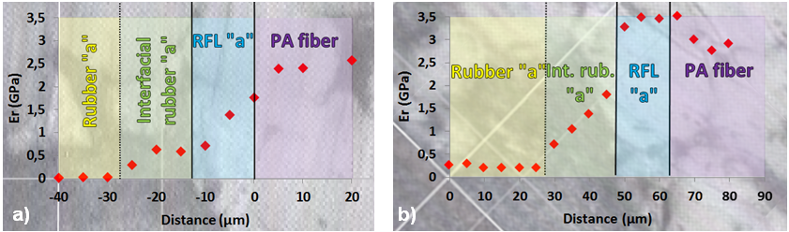
Studied belts are composite products made of bulk EPDM rubbers and polyamide reinforcement treated with resorcinol formaldehyde latex (RFL). All these constitutive materials suffer from thermal variations and interfacial chemical diffusions during co-curing process. For the aim of the present study, belts were damaged at different fatigue times (under 100°C at 24Hz) and evolutions of local moduli (calculated from the method of Oliver and Pharr [1][2]) were monitored (figure 1).
Figure 1 : Moduli profiles on the new belt, a) as received, b) after 44 million cycles
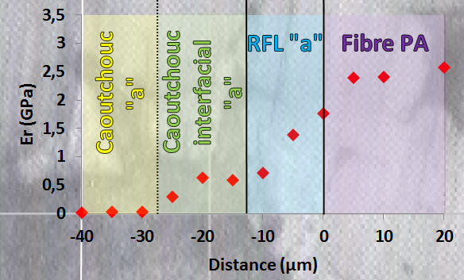
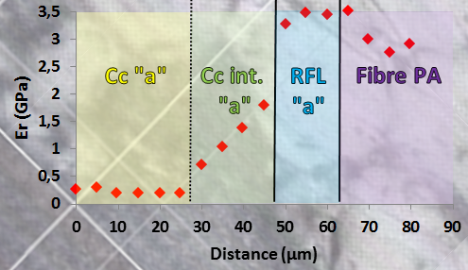
Nanoindentation allows testing at relevant scale and studying adhesion problems within belts [3].
a)
b)
a)
Figure 2 : Profils de modules d'indentation sur courroie sans perchloréthylène, a) à neuf, b) à 44MC
b)
a)
Figure 3 : Profils de modules d'indentation sur courroie sans perchloréthylène, a) à neuf, b) à 44MC
EPDM belts with polyamide cords and an interfacial rubber layer have been studied in the past (PhD thesis of Chloé Valantin, 2014 [4]) and the analysis revealed an increase of moduli at the RFL/interfacial rubber layer interface. In this study, a newly formulated belt (still composed of EPDMs, RFL and polyamide), which is more robust than the previous one, has been characterized.
Nanoindentation results correlated with SEM observations confirm the robustness of the new belt as a lower hardening and debonding of constitutive layers is obtained after fatigue damage.

References
[1] Oliver W.C. ; Pharr G.M., 1992, An improved technique for determining hardness and elastic modulus using load and displacement sensing indentation experiments, 20p.
[2] Oliver W.C. ; Pharr G.M., 2004, Measurement of hardness and elastic modulus by instrumented indentation: Advances in understanding and refinements of methodology, J. Mater. Res., 18p.
[3] Valantin C. ; Lacroix F. ; Deffarges M-P. ; Morcel J. ; Aït Hocine N., 2014, Interfacial damage on fatigue-loaded textile-rubber composites, J. Appl. Polym. Sci., 13p.
[4] Valantin C., 2014, Compréhension des mécanismes d’endommagement de l’interface textile/caoutchouc, Thèse de l’Université François Rabelais de Tours, 295p.

